Table Creation (DDL Operations)

Student ID1: 23-52314-2 Name: FARHAN CHOWDHURY | StudentID3: 23-50713-1 Name: MD. ABDUR RAUF
StudentID2: 23-52361-2 Name: NAYEM SIDDIKI | StudentID4: 23-52586-2 Name: MD AL MURSALIN
CO4: Creating DML, DDL using Oracle and connection with ODBC/JDBC for existing JAVA application
PO-e-2: Use modern engineering and IT tools for the prediction and modeling of complex computer science and engineering problem |  | Marks

Table 01:
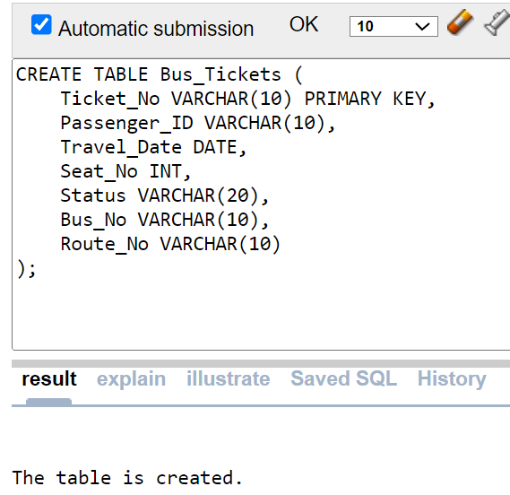

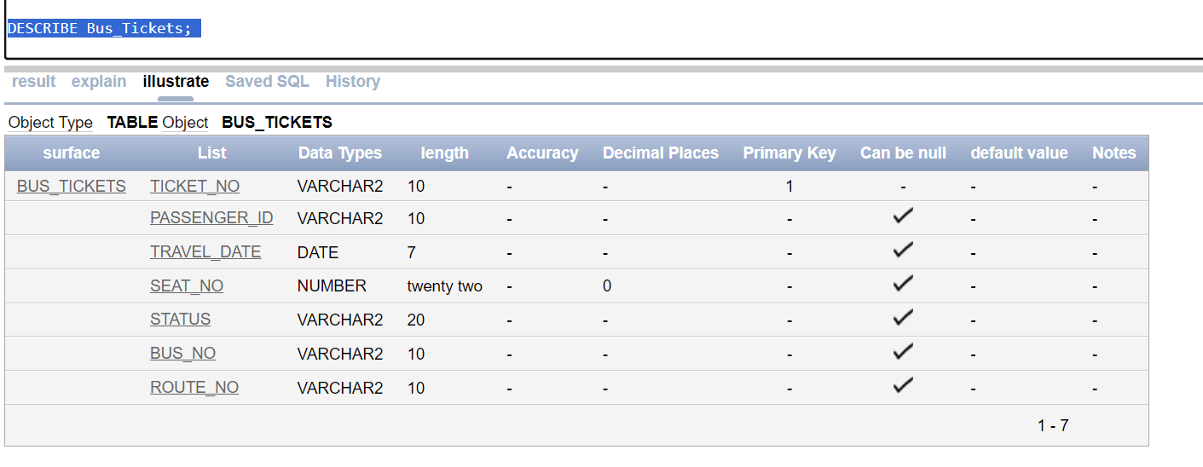

Table 02:
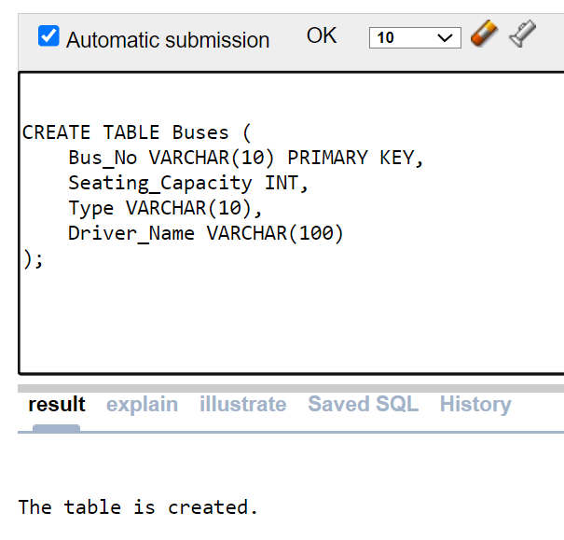

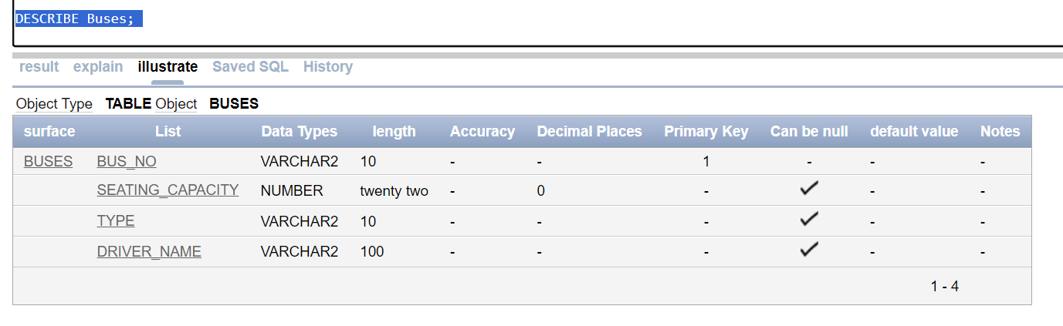

Table 03:
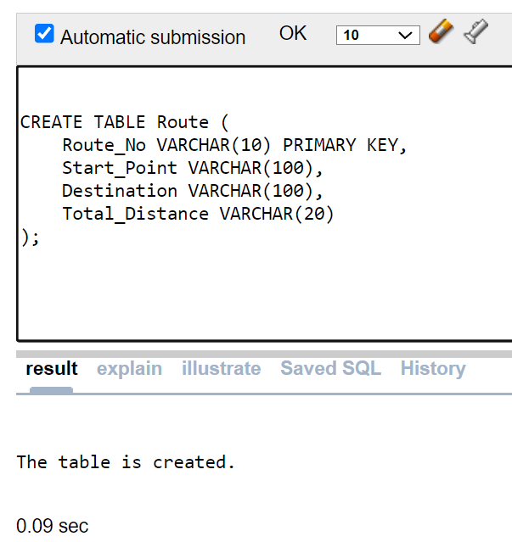

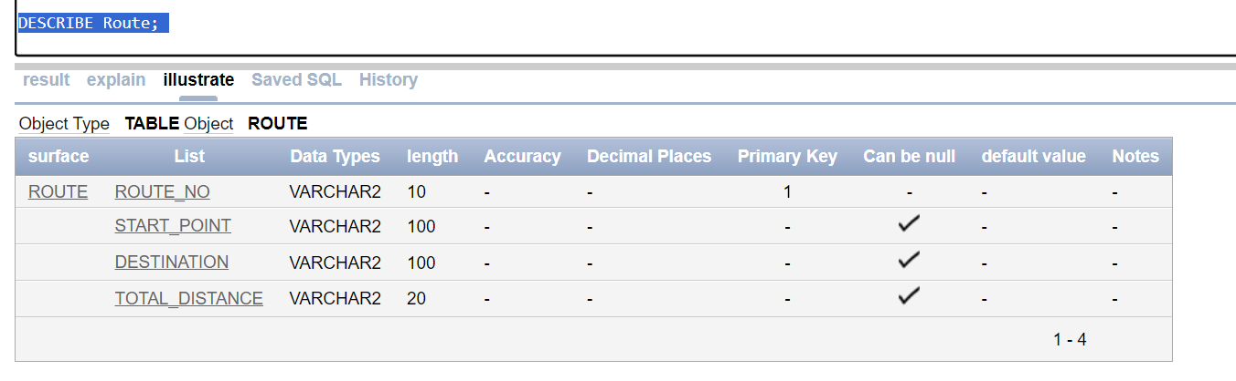

Table 04:
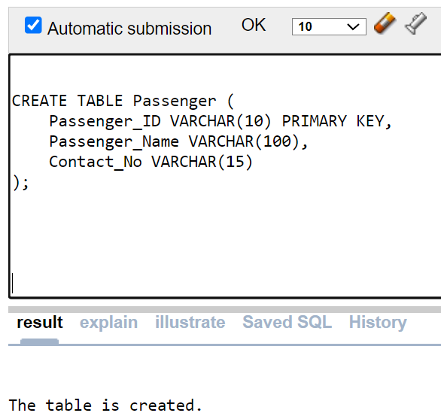

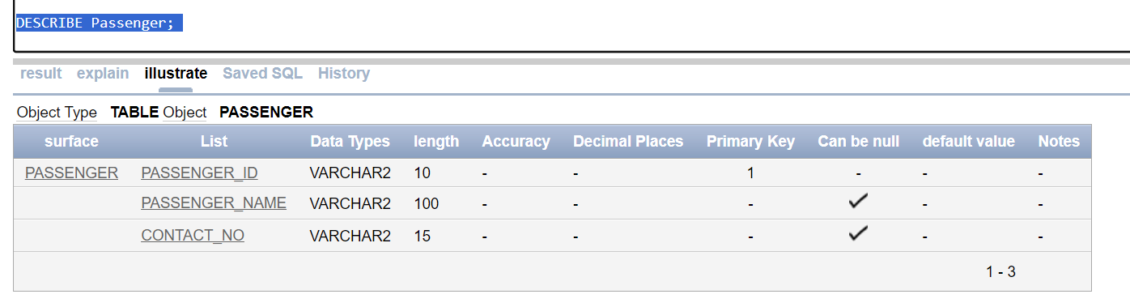

Inserted Values in the tables

Table: 01
-- Insert values into the Bus_Tickets table
INSERT INTO Bus_Tickets (Ticket_No, Passenger_ID, Travel_Date, Seat_No, Status, Bus_No, Route_No) VALUES ('T001', 'P001', TO_DATE('2024-09-18', 'YYYY-MM-DD'), 10, 'Confirmed', '001', '101');
INSERT INTO Bus_Tickets (Ticket_No, Passenger_ID, Travel_Date, Seat_No, Status, Bus_No, Route_No) VALUES ('T002', 'P002', TO_DATE('2024-09-18', 'YYYY-MM-DD'), 12, 'Booked', '001', '101');
INSERT INTO Bus_Tickets (Ticket_No, Passenger_ID, Travel_Date, Seat_No, Status, Bus_No, Route_No) VALUES ('T003', 'P003', TO_DATE('2024-09-19', 'YYYY-MM-DD'), 5, 'Confirmed', '002', '102');
INSERT INTO Bus_Tickets (Ticket_No, Passenger_ID, Travel_Date, Seat_No, Status, Bus_No, Route_No) VALUES ('T004', 'P004', TO_DATE('2024-09-19', 'YYYY-MM-DD'), 8, 'Canceled', '002', '102');
INSERT INTO Bus_Tickets (Ticket_No, Passenger_ID, Travel_Date, Seat_No, Status, Bus_No, Route_No) VALUES ('T005', 'P005', TO_DATE('2024-09-20', 'YYYY-MM-DD'), 15, 'Booked', '003', '103');

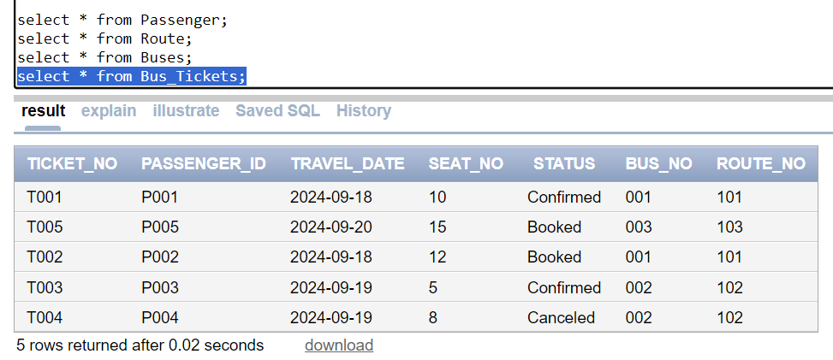

Table: 02
-- Insert values into the Buses table
INSERT INTO Buses (Bus_No, Seating_Capacity, Type, Driver_Name) VALUES ('001', 50, 'AC', 'John Doe');
INSERT INTO Buses (Bus_No, Seating_Capacity, Type, Driver_Name) VALUES ('002', 40, 'Non-AC', 'Jane Smith');
INSERT INTO Buses (Bus_No, Seating_Capacity, Type, Driver_Name) VALUES ('003', 55, 'AC', 'Mike Green');

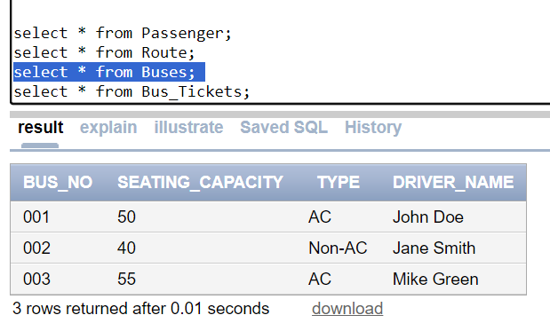

Table: 03
-- Insert values into the Route table
INSERT INTO Route (Route_No, Start_Point, Destination, Total_Distance) VALUES ('101', 'City A', 'City B', '200 km');
INSERT INTO Route (Route_No, Start_Point, Destination, Total_Distance) VALUES ('102', 'City C', 'City D', '150 km');
INSERT INTO Route (Route_No, Start_Point, Destination, Total_Distance) VALUES ('103', 'City E', 'City F', '300 km');

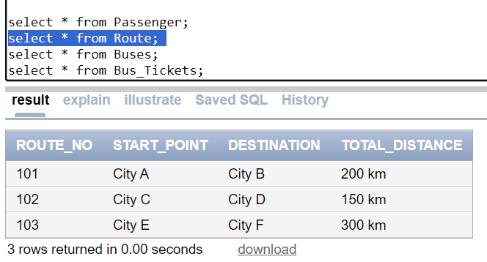

Table: 04
-- Insert values into the Passenger table
INSERT INTO Passenger (Passenger_ID, Passenger_Name, Contact_No) VALUES ('P001', 'Alice Green', '1234567890');
INSERT INTO Passenger (Passenger_ID, Passenger_Name, Contact_No) VALUES ('P002', 'Bob Brown', '0987654321');
INSERT INTO Passenger (Passenger_ID, Passenger_Name, Contact_No) VALUES ('P003', 'Carol White', '1122334455');
INSERT INTO Passenger (Passenger_ID, Passenger_Name, Contact_No) VALUES ('P004', 'David Black', '6677889900');
INSERT INTO Passenger (Passenger_ID, Passenger_Name, Contact_No) VALUES ('P005', 'Eve Brown', '2233445566');

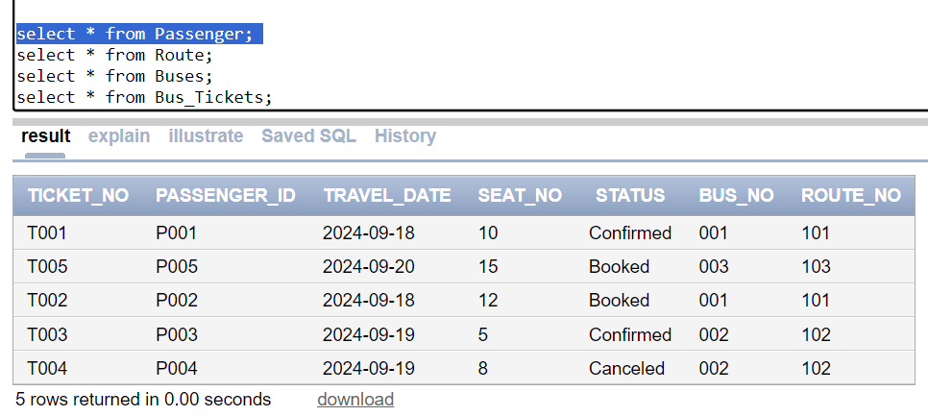

Query Test in DB
## There will be one simple query. One with Group/ Aggregate function, 2 single row Subquery, 2 Multiple Row subquery, 4 different types of joining.

a) Simple Query
Question: Print details from ticket table where status is confirmed.
= SELECT TICKET_NO, TRAVEL_DATE, SEAT_NO FROM BUS_TICKETS WHERE STATUS = 'CONFIRMED';
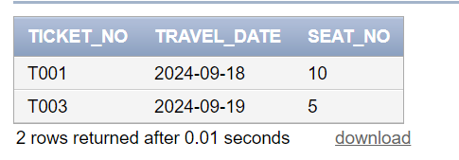

b) Query with a Single Row Function
Question: Find the name of the passenger who has the longest contact number.
= SELECT PASSENGER_NAME FROM PASSENGER WHERE LENGTH(CONTACT_NO) = (SELECT MAX(LENGTH(CONTACT_NO)) FROM PASSENGER);
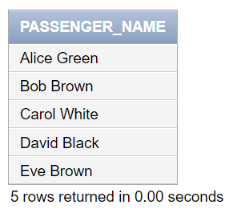

C) Query with a Multiple Row Function / Aggregate Function
Question: Calculate the total number of booked tickets for each travel date.
= SELECT TRAVEL_DATE, COUNT(*) AS TOTAL_BOOKED FROM BUS_TICKETS WHERE STATUS = 'BOOKED' GROUP BY TRAVEL_DATE;GROUP BY TRAVEL_DATE;
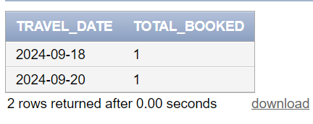

d) 2 Single Row Subqueries and 2 Multiple Row Subqueries
Single Row Subqueries:
- Question: Find the name of the passenger with Ticket_No 'T001'.
= SELECT PASSENGER_NAME FROM PASSENGER WHERE PASSENGER_ID = (SELECT PASSENGER_ID FROM BUS_TICKETS WHERE TICKET_NO = 'T001');
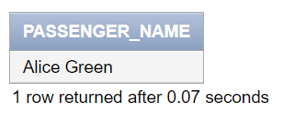

- Question: Get the seating capacity of the bus with Bus_No '002'.
= SELECT SEATING_CAPACITY FROM BUSES WHERE BUS_NO = (SELECT BUS_NO FROM BUS_TICKETS WHERE TICKET_NO = 'T004');
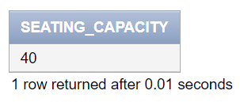

Multiple Row Subqueries:
- Question: Find all passengers who have booked tickets on the same travel date as '2024-09-18'.
= SELECT PASSENGER_NAME FROM PASSENGER WHERE PASSENGER_ID IN (SELECT PASSENGER_ID FROM BUS_TICKETS WHERE TRAVEL_DATE IN (SELECT TRAVEL_DATE FROM BUS_TICKETS WHERE TRAVEL_DATE = '2024-09-18'));

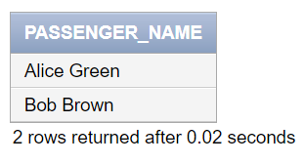

- Question: List all ticket numbers for passengers who have a contact number starting with '1'.
= SELECT TICKET_NO FROM BUS_TICKETS WHERE PASSENGER_ID IN (SELECT PASSENGER_ID FROM PASSENGER WHERE CONTACT_NO LIKE '1%');

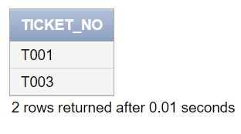

e) 4 kinds of joining
- Inner Join:
Question: Get a list of all tickets along with passenger names.
= SELECT BT.TICKET_NO, P.PASSENGER_NAME FROM BUS_TICKETS BT INNER JOIN PASSENGER P ON BT.PASSENGER_ID = P.PASSENGER_ID;

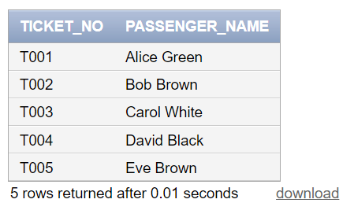

- Left Join:
Question: List all buses and their tickets (if any), showing buses even if they have no tickets.
= SELECT B.BUS_NO, BT.TICKET_NO FROM BUSES B LEFT JOIN BUS_TICKETS BT ON B.BUS_NO = BT.BUS_NO;

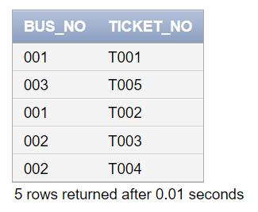

- Right Join:
Question: Get a list of all tickets and the buses they are assigned to, showing tickets even if there are no associated buses.
= SELECT BT.TICKET_NO, B.BUS_NO FROM BUS_TICKETS BT RIGHT JOIN BUSES B ON BT.BUS_NO = B.BUS_NO;
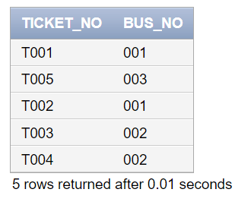

- Full Outer Join:
Question: Retrieve all passengers and their booked tickets, if any, showing all passengers and tickets.
= SELECT P.PASSENGER_NAME, BT.TICKET_NO FROM PASSENGER P FULL OUTER JOIN BUS_TICKETS BT ON P.PASSENGER_ID = BT.PASSENGER_ID;

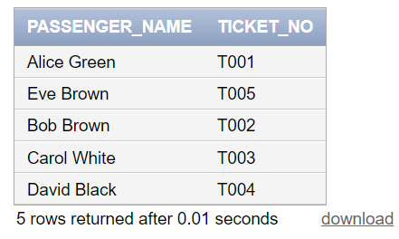

1 simple view
Question: Question: Create a view called Simple_Bus_Ticket_Info that displays ticket numbers, passenger names, and travel dates for all tickets.
= CREATE VIEW Simple_View AS
SELECT
BT.Ticket_No,P.Passenger_Name,BT.Travel_Date
FROM
Bus_Tickets BT
JOIN
Passenger P ON BT.Passenger_ID = P.Passenger_ID;

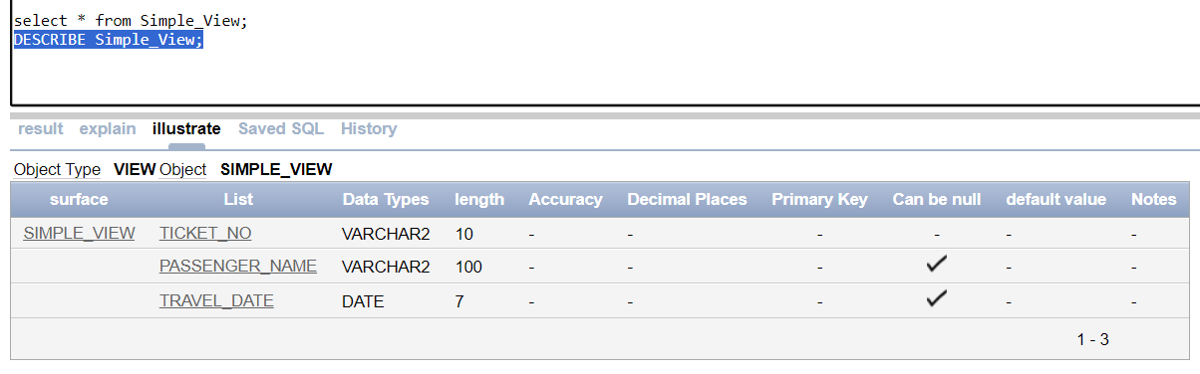

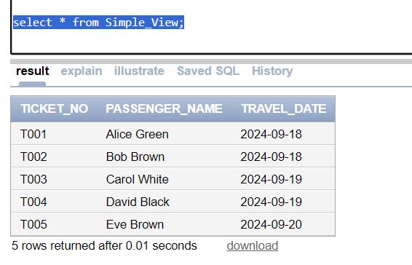

1 complex view
Question: Create a view called Complex_View that includes ticket numbers, passenger names, travel dates, seat numbers, bus details, and route information, ensuring that all records are included from all relevant tables.
= CREATE VIEW Complex_View AS
SELECT
BT.Ticket_No,P.Passenger_Name,BT.Travel_Date,BT.Seat_No,B.Bus_No,B.Driver_Name,R.Start_Point,R.Destination,R.Total_Distance
FROM
Bus_Tickets BT
INNER JOIN
Passenger P ON BT.Passenger_ID = P.Passenger_ID
LEFT JOIN
Buses B ON BT.Bus_No = B.Bus_No
FULL OUTER JOIN
Route R ON BT.Route_No = R.Route_No
WHERE
BT.Status = 'Confirmed' OR BT.Status IS NULL;
